Here's a question related to the provided code:

**\*\*Question:\*\*** In the Java program, two classes, `Icecream.java` and `Test.java`, are defined. The `Icecream` class represents ice cream with attributes like type, company, and price, and it includes a method for checking equality. The `Test` class creates two ice cream objects and compares them. Explain the structure and purpose of the `Icecream` class, and describe what happens when you create `I1` and `I2` ice cream objects and call the `equals` method. What will be the output of the `System.out.println(I1.equals(I2));` statement in the `Test` class?

**Answer:**

- The `Icecream` class stores information about ice cream, including type, company, and price. It has a `tostring` method for generating a string representation and an `equals` method to check if two ice cream objects are equal based on their attributes.

- In the `Test` class, two `Icecream` objects, `I1` and `I2`, are created with the same type, company, and price.

- The `equals` method of the `Icecream` class is called to compare `I1` and `I2` attributes.

- The output of `System.out.println(I1.equals(I2));` will be `true` because `I1` and `I2` have the same type, company, and price, making them equal according to the `equals` method.

Lesson for this code:

**1. toString() method**

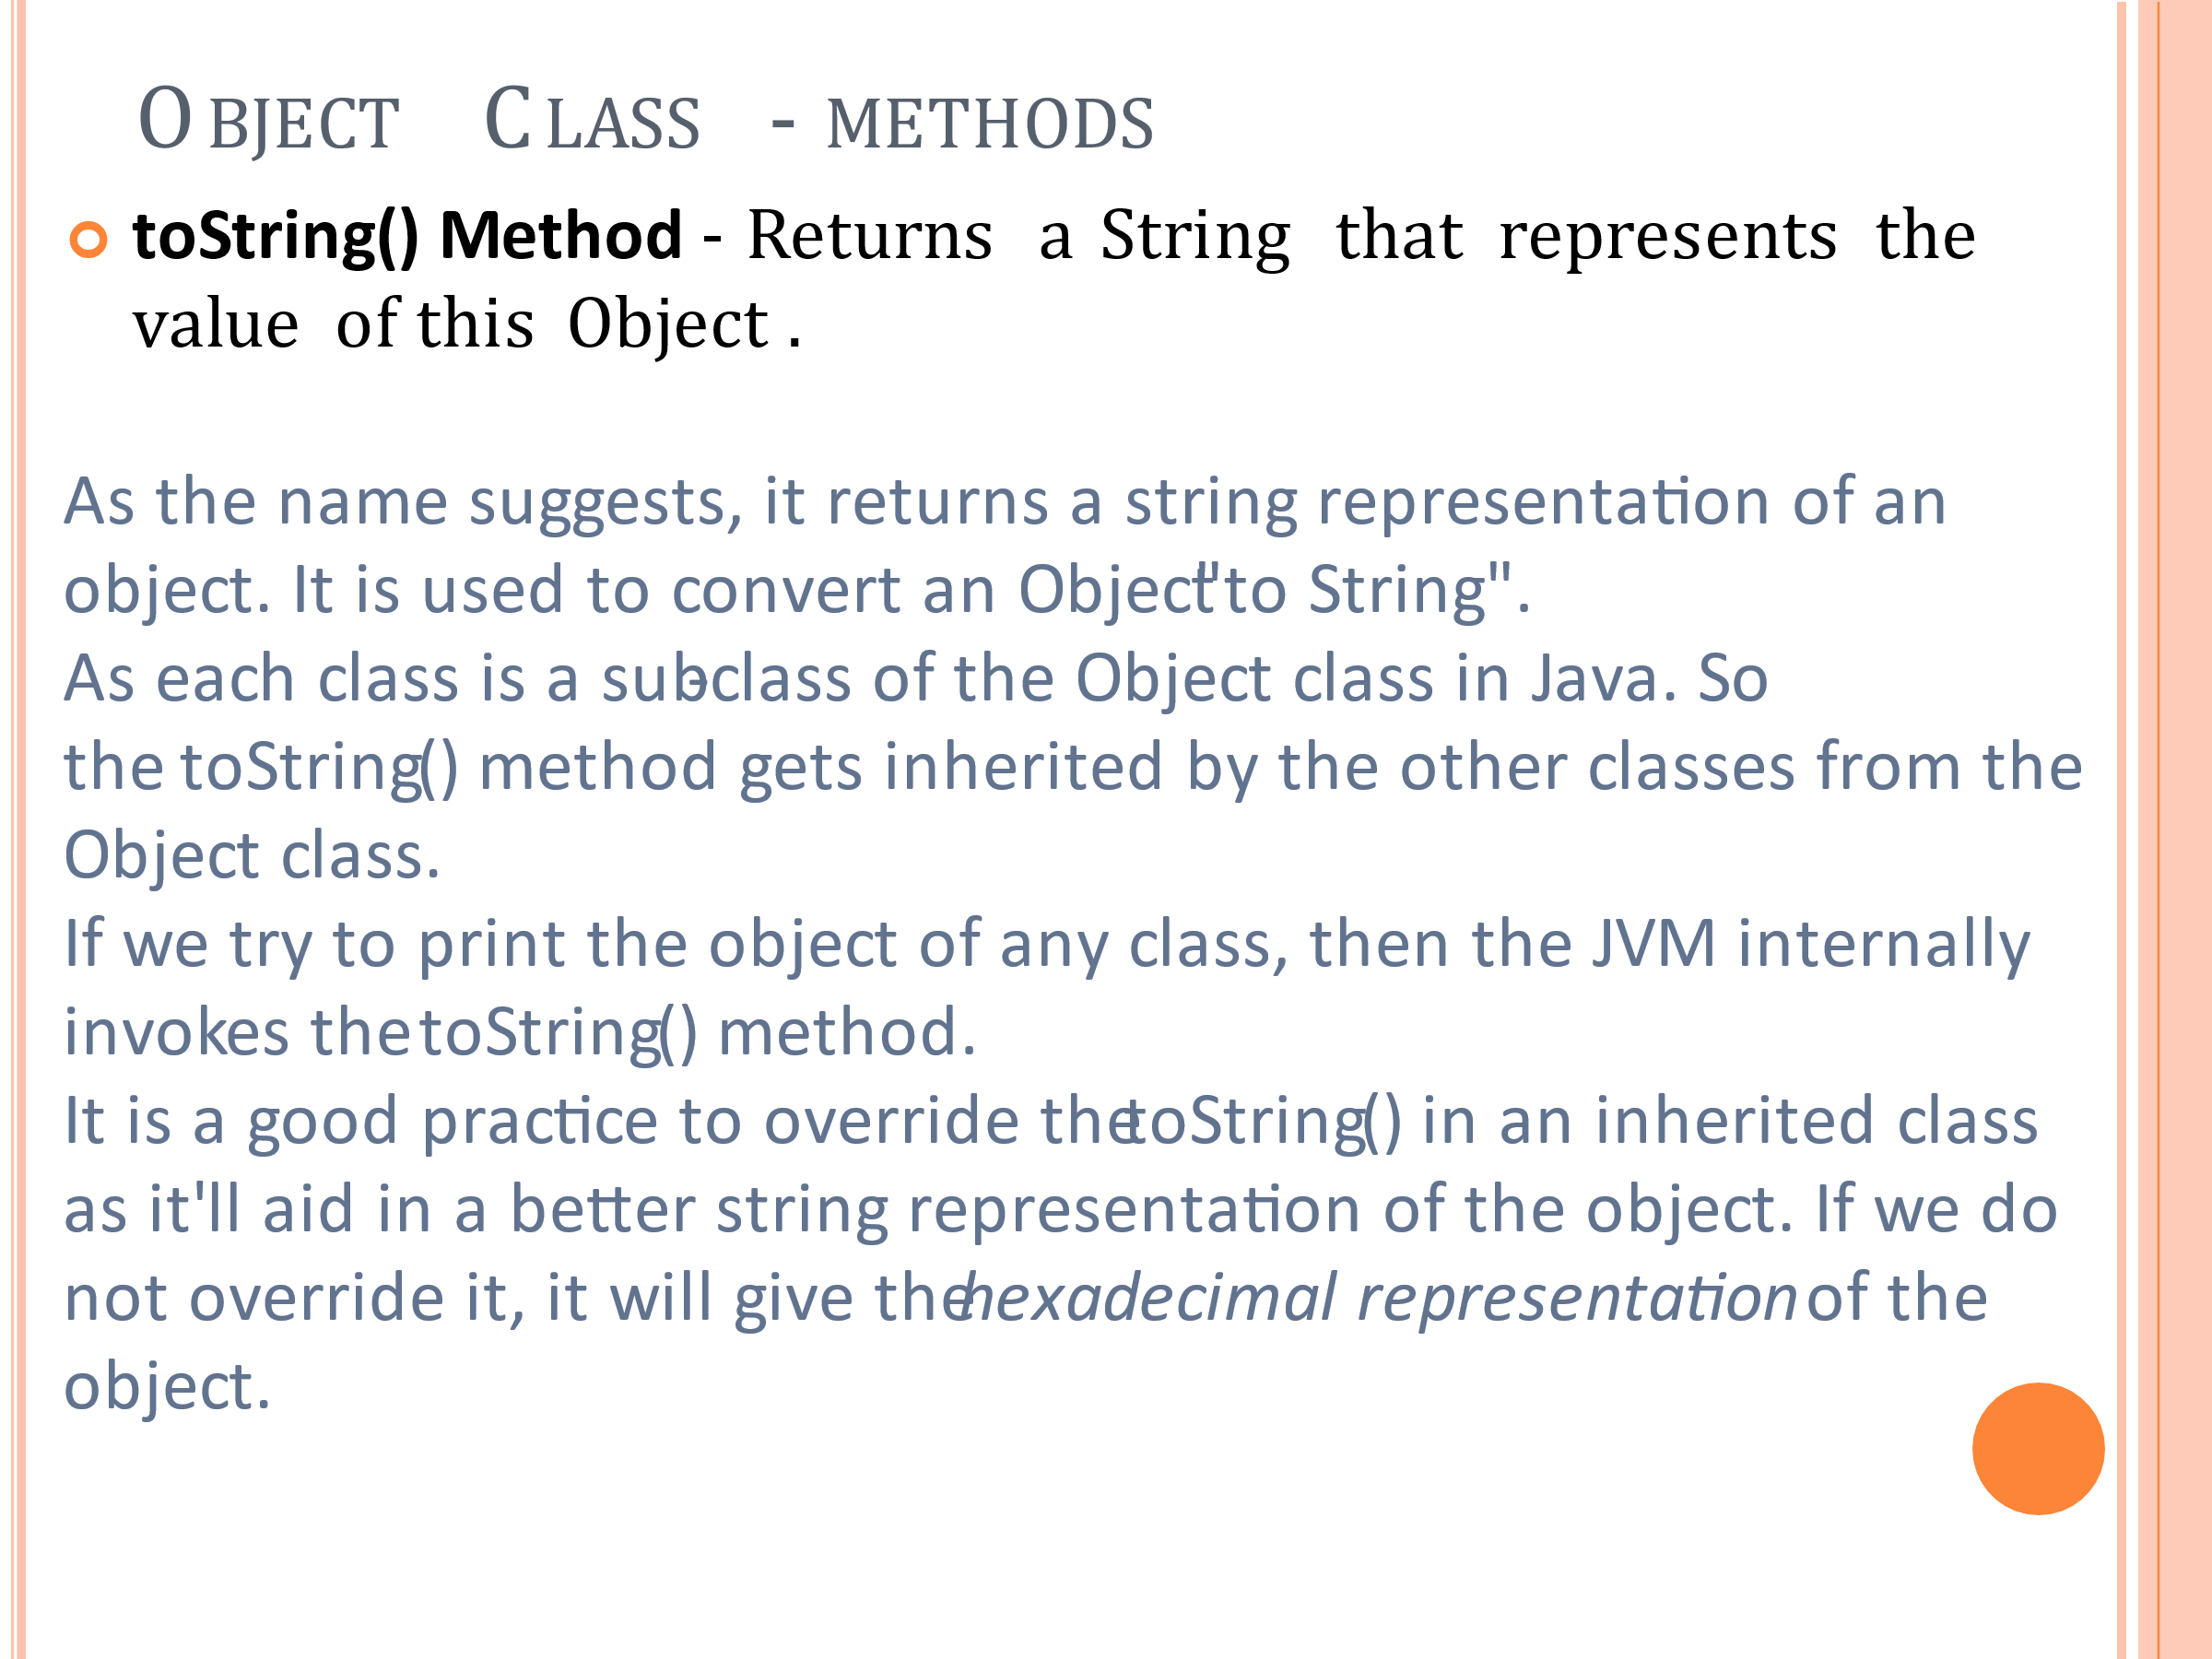

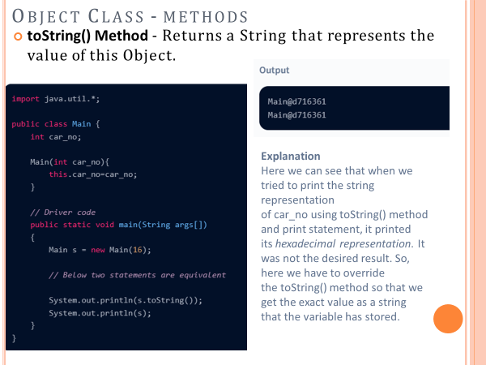

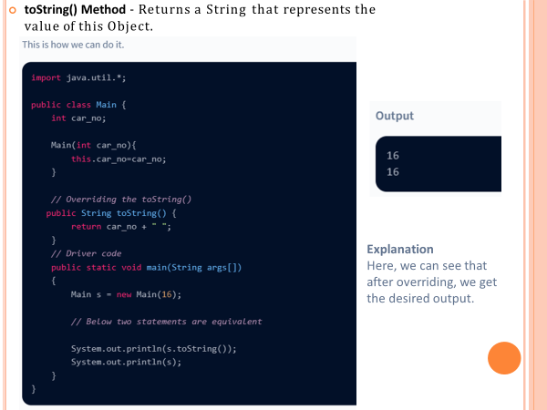

**2. equals(Object obj) method**

It compares the given object to “this” object (the object on which the method is called). It gives a generic way to compare objects for equality. It is recommended to override the **equals(Object obj)** method to get our own equality condition on Objects.

For more on the override of equals(Object obj) method refer – [Overriding equals method in Java](https://www.geeksforgeeks.org/overriding-equals-method-in-java/)

***Note:****It is generally necessary to override the****hashCode()****method whenever this method is overridden, so as to maintain the general contract for the hashCode method, which states that equal objects must have equal hash codes.*

For Further Reading:

[Object Class in Java - Scaler Topics](https://www.scaler.com/topics/object-class-in-java/)

[Object Class in Java - GeeksforGeeks](https://www.geeksforgeeks.org/object-class-in-java/)  
[Java Object Class - Javatpoint](https://www.javatpoint.com/object-class)

[Object Cloning in java - Javatpoint](https://www.javatpoint.com/object-cloning)